PROLICHT presents new colours at the Austrian Design Exhibition

March 2019 – Under the motto "Pleasure & Treasure", the Austrian furniture and design industry will be presenting itself at the Fuorisalone in Milan this year. Among the selected brands is the Tyrolean lighting manufacturer PROLICHT, which stands for innovative and tailor-made lighting solutions.

Individualisation is very important to PROLICHT. Because no space, no object and no moment are alike, and because every task and every customer requirement is unique, bespoke luminaires make a significant difference in interior design. Each luminaire is produced on order and exactly according to the wishes of the customer. There is a large selection of configuration options available for each luminaire in advance.

In addition to form, types of installation and lighting technology, these configuration options also included the selection of 25 unique colours with which the luminaires could be finished. These colours have now been extended by a metal edition in spring 2019: "26 Champagne Cream", "27 Copper Mine", "28 Ancient Bronze" and "29 Jazz Gold" now complete the colour palette of PROLICHT.

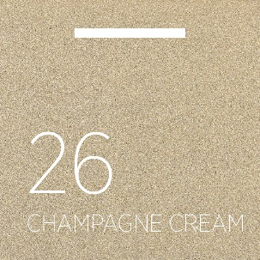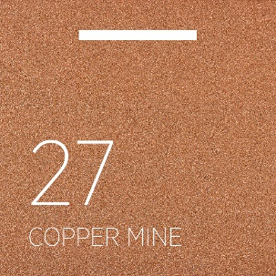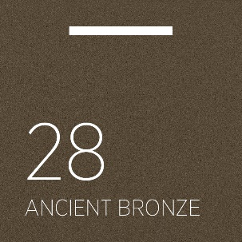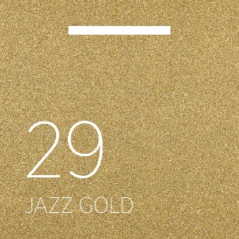

Colour creates the basis for creativity - with colours you give a room an optical as well as emotional face and the right colour selection is an essential point in every conception. Small colour accents can make a big difference - PROLICHT knows that too and now offers a choice of 25+5 different colours (including a natural aluminium look) to adapt every luminaire design to the respective overall concept or to set brilliant highlights.

At the Austrian Design Exhibition, PROLICHT's new colours will be presented to the public for the first time. The innovative SNOOKER luminaire - which has been available since fall 2018 as a single luminaire with built-in and surface mounted canopy and variable length of rope - will be presented in the new metal edition at the Sala Reale at Milan's central station.

Furthermore, the architecture studio Vasku & Klug creates the framework for the exhibition, which will show the luminaires and all other "Made in Austria" products with a unique and particularly unusual design concept.

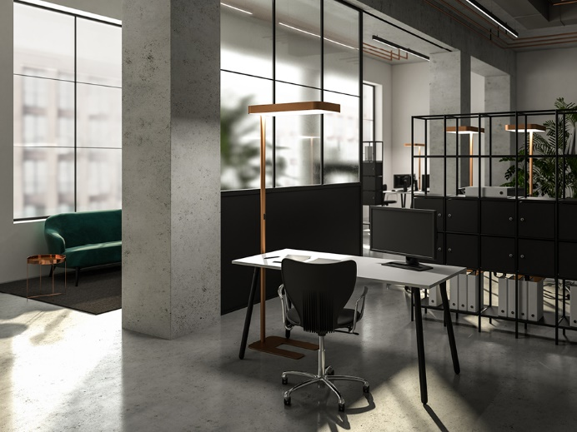
@-WORK in 27 Copper Mine

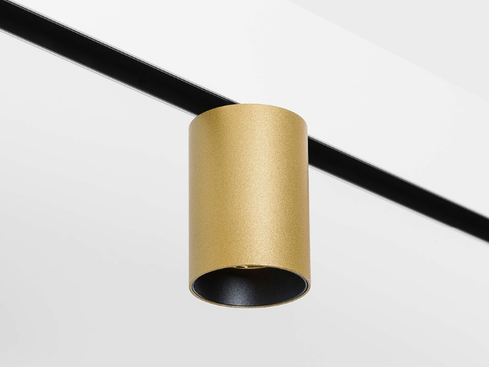
CENTRIQ in 29 Jazz Gold

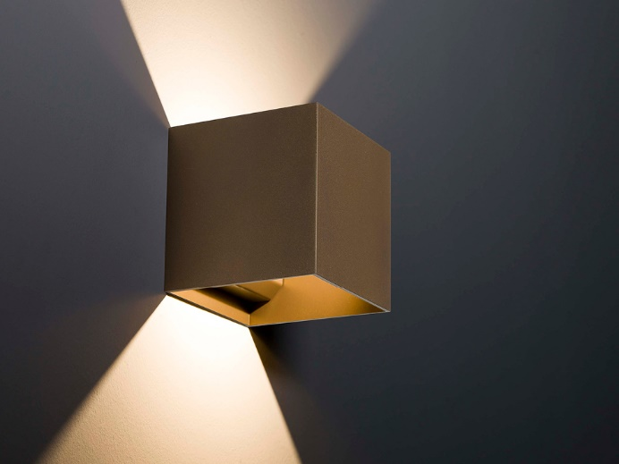
DICE in 28 Ancient Bronze

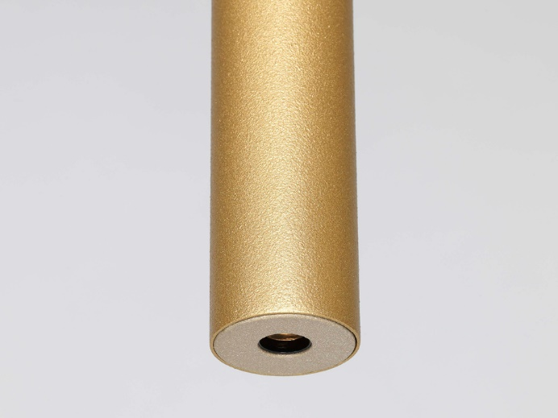
HANGOVER PLUG in 29 Jazz Gold and LFO cover in 26 Champagne Cream

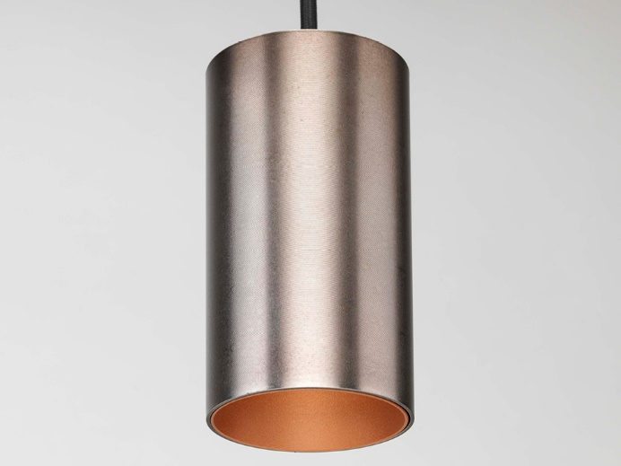
HANGOVER in 25 Gunmetal and Korona Cone in 27 Copper Mine

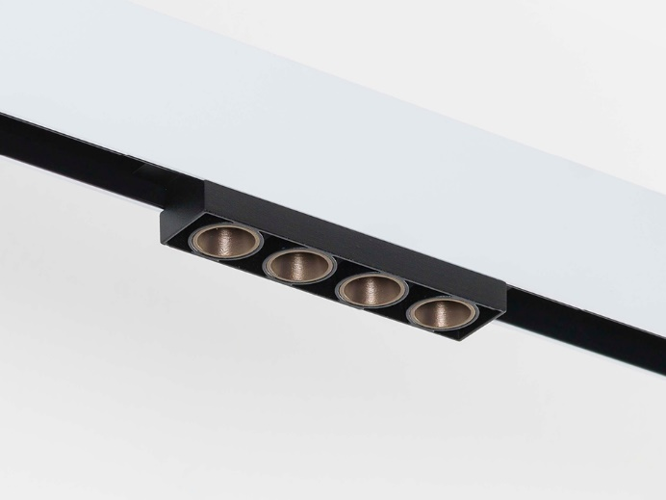
MAGIQ with Korona Cones in 28 Ancient Bronze
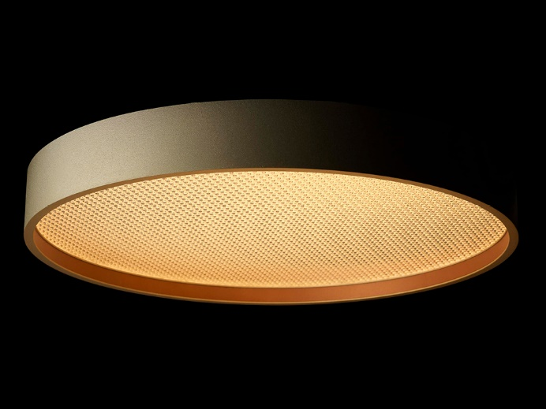
SIGN in 26 Champagne Cream and Korona Frame in 27 Copper Mine

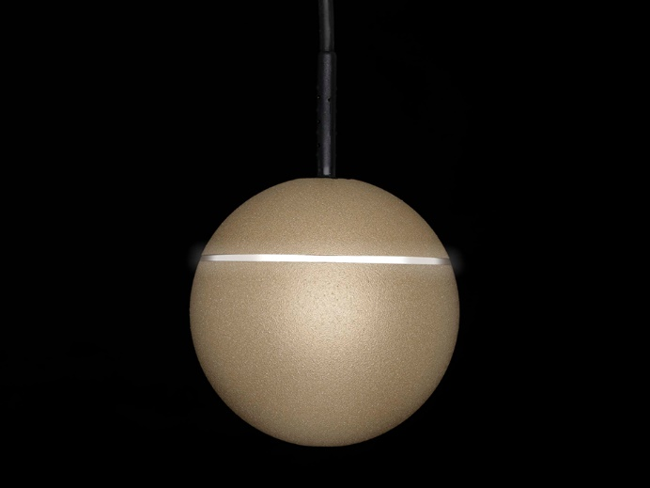
SNOOKER in 26 Champagne Cream and white Shine Ring

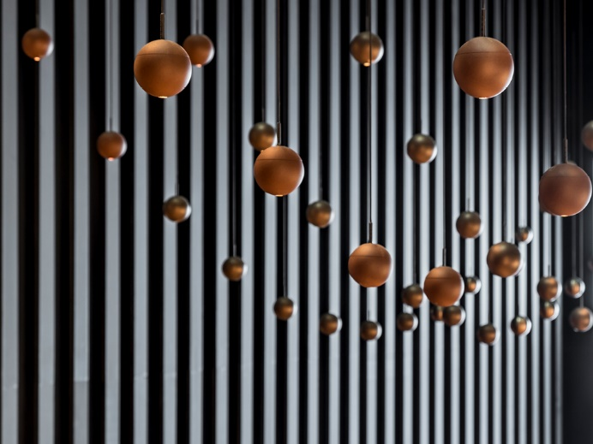
SNOOKER in 27 Copper Mine

All pics: ©PROLICHT
To download at:
https://we.tl/t-do47qT0fvO
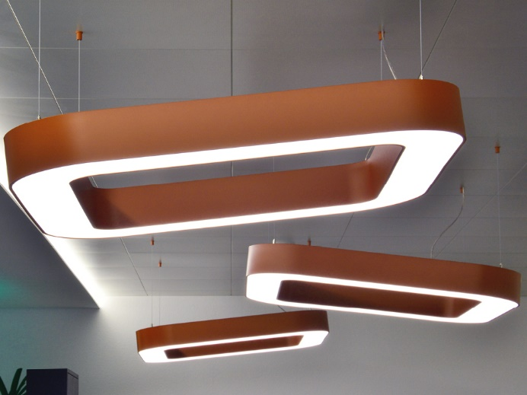
Quantum in 27 Copper Mine

