Light + Building 2018 innovations: SNOOKER
Rooms model with light
Neu-Goetzens, March 2018 – Suspended luminaire with cozy and glare-free light, flexible light object, kinetic art installation - all this is SNOOKER, and much more. The "more" is defined by the designer who can plan and model his personal, tailor-made light sculpture with SNOOKER. With the new development, PROLICHT provides the planner with a lighting tool that the lighting industry has not yet seen.

In high-quality meeting places such as restaurants, bars or hotel lobbies, the goal is to create a communicative and comfortable atmosphere. The guests should feel comfortable and stay a long time. In such rooms, a successful lighting concept is a prerequisite for successful operation. For example, tables and seating arrangements should be dipped in a pleasant, high-quality and directional light. The spherical SNOOKER luminaires meet these lighting requirements with flying colors. The DALI dimmable LED pendant luminaires with their high color rendering index of CRI> 90 are equipped with the latest Bartenbach DUAL FOCUS LFO lenses, which allow a glare-free viewing angle of only 55 degrees.
Above all, however, SNOOKER is a lighting instrument with which the designer can compose his personal "Sound of Light". Because with SNOOKER you can react to changing conditions of use or table arrangements, since the luminaires - or groups of luminaires - can be adjusted in height and position at any time according to your needs. This unique creative and playful structure of the system is based on the innovative technology GRAVITY LIFT, with which variable light arrangements can be created in the room.

Flexible, variable, adaptable - SNOOKER
GRAVITY LIFT is the key component of the SNOOKER system. It allows infinite vertical adjustment of the pendant luminaire over 1.5 meters with the option of extending the suspension cable by another three meters. Thanks to the extension, even very high rooms can be used. A good audible click every 10 centimeters helps to set the suspension height, especially if a group of lights is to be set to the same height. If the SNOOKER luminaires are magnetically latched into the G-50 CHANNEL profile systems, the luminaires can not only be adjusted vertically above the LIFT, but also horizontally change their position. PROLICHT calls this innovative solution, which can react flexibly to changing table layouts in lobbies or restaurants at any time, "SERVING with GRAVITY LIFT". Under "MODELING WITH GRAVITY LIFT" PROLICHT gives the designer the freedom to compose a kinetic light sculpture - most easily via the specially developed online configurator. For example, free wave or arcuate installations can be intuitively generated with the solution.
Thanks to a simple docking system, the spherical SNOOKER elements with a diameter of 72 millimeters can be changed quickly. And since PROLICHT offers the balls as a SHINE version with an additional illuminated ring in six different colors and also as a non-luminous variant, countless design variations are possible. Like almost all PROLICHT luminaires, SNOOKER can be finished in all 25 PROLICHT colors.
SNOOKER is either installed in the specially developed surface-mounted or rimless installation profile G-50 CHANNEL (48 V DC) or alternatively on the so-called G-BOARDS. These diamond-shaped and modular ceiling elements are surface-mounted and can accommodate up to four SNOOKERs. Combined with each other, unique graphic artworks can be created on the ceiling.

PROLICHT awakens the play instinct in the designer
PROLICHT stands for creativity without limits. Ideas have to be able to live. Therefore, PROLICHT offers with new solutions the possibility to create something new every day and to play imaginatively with concepts. The new SNOOKER system is the best example of this claim. PROLICHT develops and manufactures tailor-made lighting solutions in the middle of Europe, in the heart of the Tyrolean Alps. Founder and Managing Director Walter Norz and his team of qualified technicians, engineers and designers have been creating individual lighting solutions from batch size 1 onwards for 25 years, tailored to the wishes and requirements of architects, designers and creative people. The 200 employees produce in Neu-Goetzens in record time and it is 98.6 percent delivered on time - usually within five days.
Reprint free of charge / specimen copy requested
Images:
You can download these and other pictures in high and low resolution under the following link at RUESS PUBLIC B:
https://filetransfer.ruess-group.com/public/312223

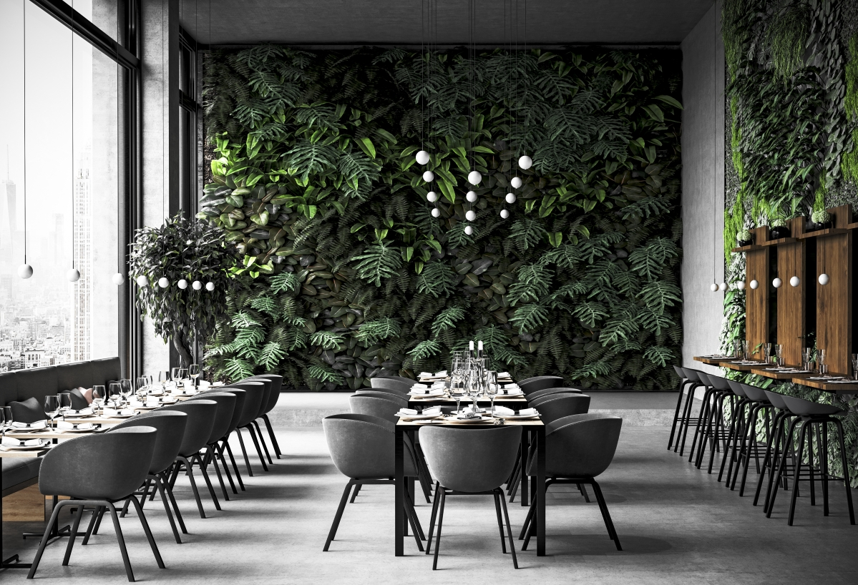
Caption: With the novelty SNOOKER, restaurants can be illuminated in a high-quality, glare-free manner.

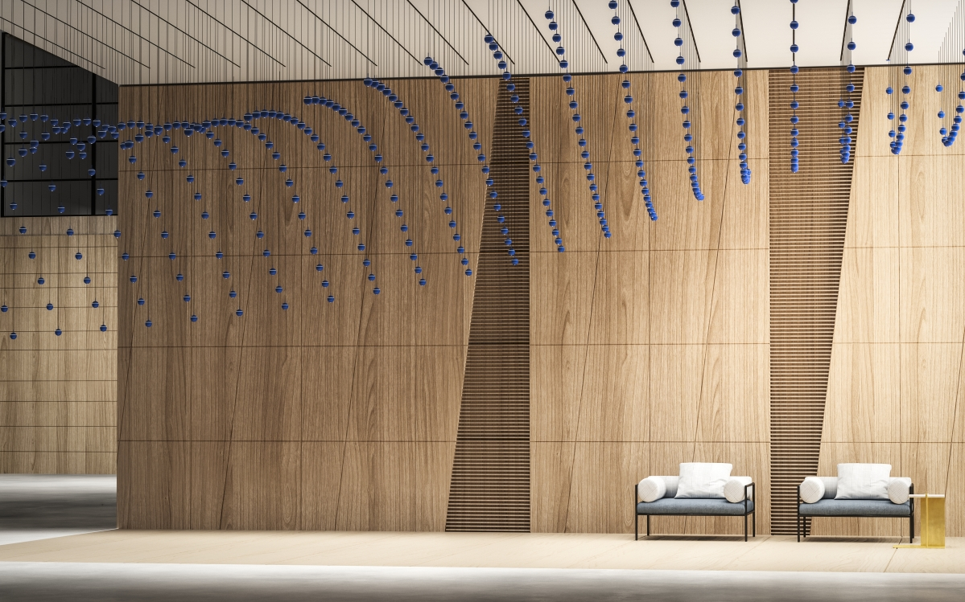
Caption: Kinetic sculptures can also be realized with SNOOKER.

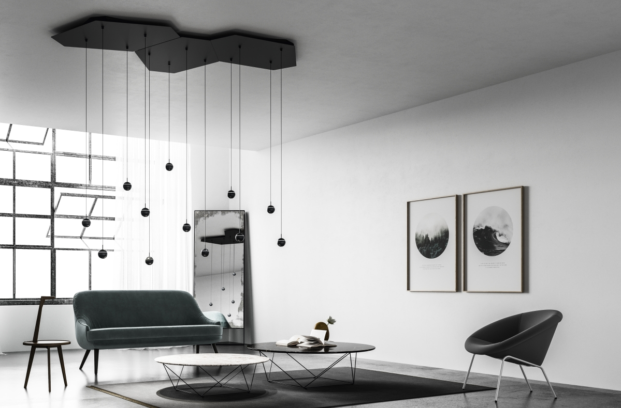
Caption: With the modular surface-mounted panels "G-BOARD for GRAVITY LIFT" the ceiling becomes a work of art.

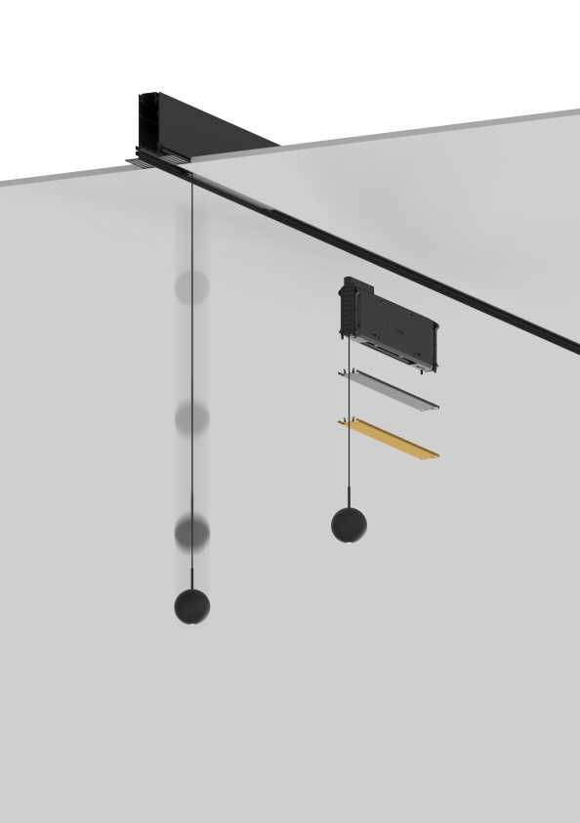
Caption: With the GRAVITY LIFT, SNOOKER can be integrated into rimless built-in or surface-mounted rail systems.
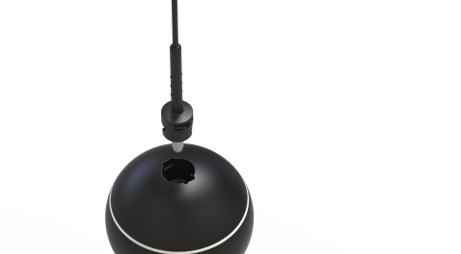
Caption: Thanks to an innovative docking system, the SNOOKER balls can be easily exchanged.

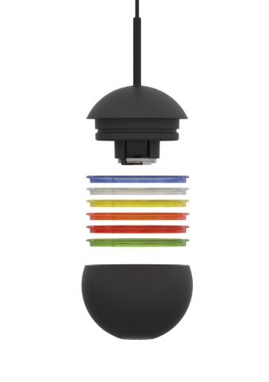
Caption: Color always comes into play with PROLICHT. SNOOKER can be finished in all 25 PROLICHT colors and additionally equipped with a light ring.

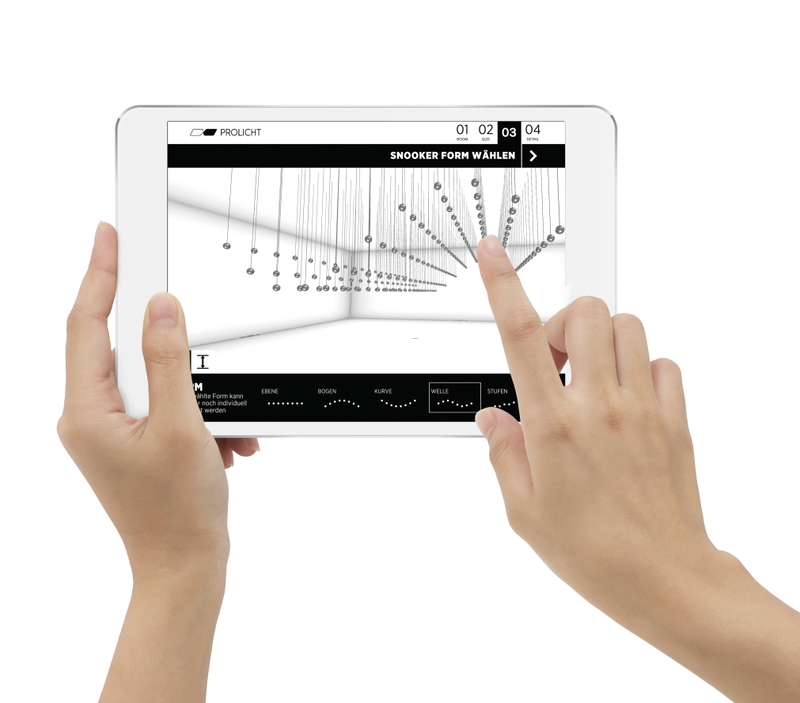
Caption: With the new online configurator, kinetic forms can be created.

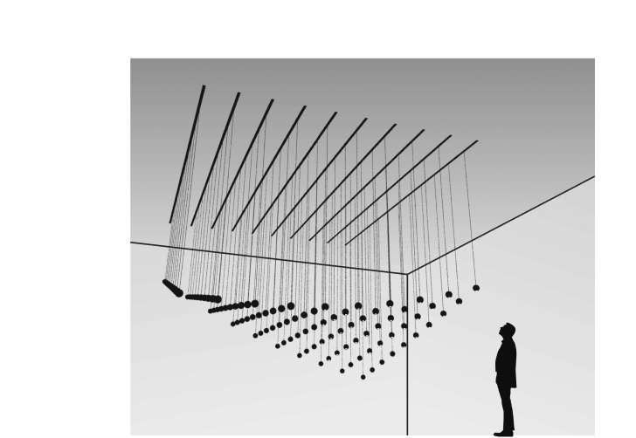
Caption: SNOOKER gives free rein to creativity.

All photos: PROLICHT

About PROLICHT

PROLICHT is a worldwide successful premium manufacturer of architectural lighting concepts. Individual lighting solutions are developed and built for professional needs in record time. As an international company, PROLICHT operates the production and assembly plant at its main location in Tyrol, as well as a global sales network with partners in more than 70 countries.
The company specializes in the production of architectural luminaires and lighting systems for the shop and retail sector, offices, public buildings, hotels and restaurants. The Tyrolean company today employs around 200 people.
Efficient processes, a clear commitment to the production location Tyrol, as well as a lean organization form the basis of the economic success of PROLICHT GmbH. Ecological and social sustainability in the value chain, comprehensive product responsibility and conservation of resources are firmly anchored in the corporate strategy.

Lighting solutions that make a difference. PROLICHT

Your contact in the company:
PROLICHT GmbH
Markus Kirchmair
Marketing Director
T +43 5234 33499 27
markus.kirchmair@prolicht.at

PROLICHT GmbH
Gewerbepark 9 | A-6091 Götzens
T +43 5234 33499 38 | F +43 5234 33499 22
www.prolicht.at

