Light + Building 2018 innovation: 2LOOK4
Customized lighting tool
Neu-Goetzens, March 2018 – Especially in the retail sector, lighting solutions are needed that maximize the appeal of a room with atmospheric lighting. Thanks to its many years of expertise in this field, the premium manufacturer PROLICHT has expanded and refined its popular lighting tool 2LOOK4 for the Light + Building trade fair.
Space and light - without one, the other loses its effect. Only through light does a room become visible, and only through spatial limitation can light reflect. This principle also applies to retail space. The lighting of a room affects the human subconscious mind and thus our feelings and decisions. And so the lighting concept decisively decides in which way the visitor is drawn into a shopping world. A good lighting concept in retail must also be very flexible, because the goods offered often change depending on the season and the seasons. Thus, lighting concepts that can be easily adapted to the respective interior and at the same time retain the basic idea of ​​lighting design are ideal. Here, high-tech and forward-looking planning is in demand: luminaires on rail systems, such as the 2LOOK4 from PROLICHT, enable constant adaptation to the point of sale.

Flexible wonder tool
The completely redesigned product family 2LOOK4 stands for minimalistic elegance and sophisticated technology - and above all for maximum flexibility. It is not for nothing that the rail system is described as a "Swiss Army Knife" for lighting applications. Knife-sharpened, rimless aluminum extruded profile systems characterize the comprehensive lighting solution, which ensures a perfect and aesthetic solution with its seamless design. The profiles can be integrated into ceilings and walls and allow the designer to draw lines in the room with light.
The family includes the track widths of 20, 25, 50, 80, 130 and 160 mm. It offers an incredible variety of architectural lighting solutions. All types use visible or hidden track spots that can be fitted with various lenses, which can either be mounted on a 48-volt magnetic track (MAGTRACK), a 230 Volt track or with a PLUG plug-in system. This tool-free installation or the uncomplicated repositioning of the spots ensures planners a high degree of design freedom. Thanks to the different uses for the system, 2LOOK4 can be used for both general lighting and illumination with spots or wall washers. Suspended luminaires, such as the new SNOOKER, can also be integrated into the rail system. The wide light channels with 80, 130 or 160 mm can even be realized with an optional backlight in the profile.
For 2LOOK4, special joints in the profiles ensure extremely clean installation. They serve a more stable connection between the materials and are cast with a gypsum-based filling compound. In this way, cracks between the aluminum and the plasterboard are avoided.
With a lighting tool such as 2LOOK4, the planner succeeds in creating the perfect sales room.

Let`s play
PROLICHT stands for creativity without limits. Ideas must be able to live. That is why PROLICHT, with its solutions such as the 2LOOK4 system, offers the opportunity to create something new every day and to play with ideas in an imaginative way. From many, many combination options, the planner at PROLICHT can create his own tailor-made product from lot size 1 onwards. This is produced by the approximately 200 employees in the heart of the Tyrolean Alps in record time - usually within five days - with passion and the highest engineering.
PROLICHT stands for tailor-made lighting with a unique lighting effect, technically sophisticated mechanics and extremely easy handling - for lighting design without compromise. This does not only apply to shops, but also to hotels, restaurants or private homes.
Reprint free of charge / specimen copy requested

Images:
You can download these and other pictures in high and low resolution under the following link at RUESS PUBLIC B:
https://filetransfer.ruess-group.com/public/e1083b
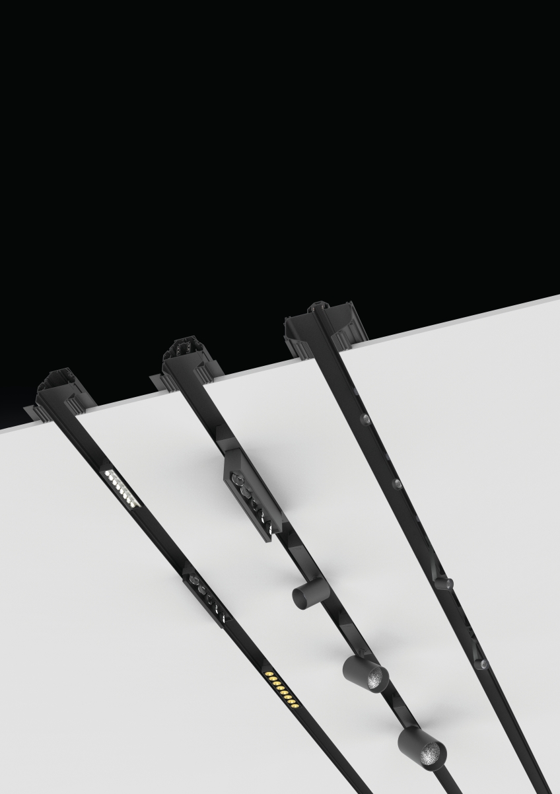
Caption: The 2LOOK4 retail tool from the Licht-Maßschneiderei PROLICHT can be flexibly equipped with spots, wallwashers, downlights, etc.
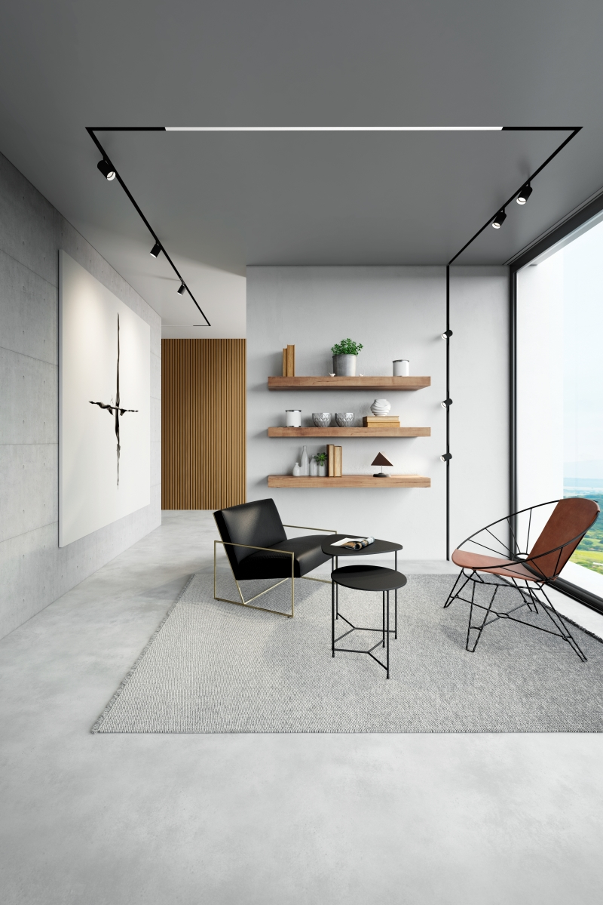
Caption: 2LOOK4 can be installed in ceilings and walls. So a room can be designed graphically.
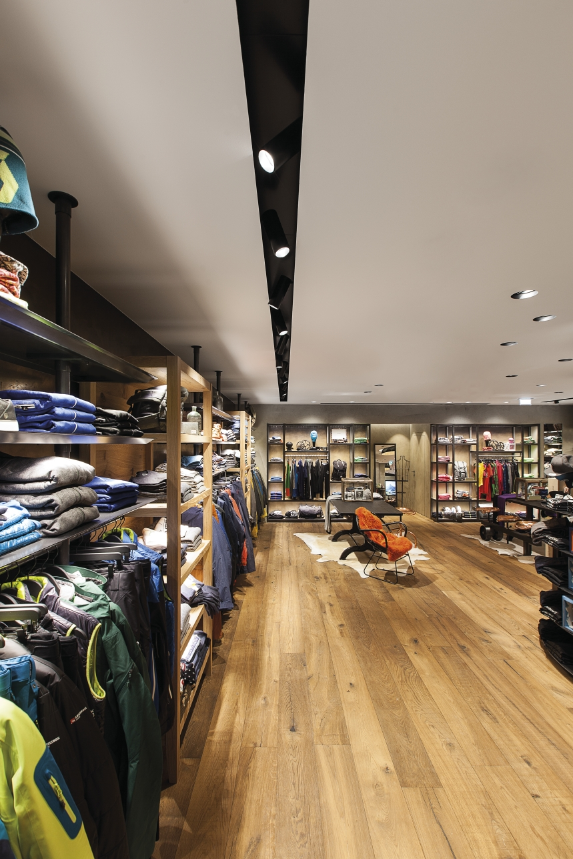
Caption: The system was already successfully used in the Shop Strolz in Lech am Arlberg
Photo credit:
Project name: Shop Strolz, Lech am Arlberg, Austria
Architect: Christian Reich
Lighting design: Shoup - Dietmar Unger
Photographer: Armin Kuprian

All other photos: PROLICHT
About PROLICHT

PROLICHT is a worldwide successful premium manufacturer of architectural lighting concepts. Individual lighting solutions are developed and built for professional needs in record time. As an international company, PROLICHT operates the production and assembly plant at its main location in Tyrol, as well as a global sales network with partners in more than 70 countries.
The company specializes in the production of architectural luminaires and lighting systems for the shop and retail sector, offices, public buildings, hotels and restaurants. The Tyrolean company today employs around 200 people.
Efficient processes, a clear commitment to the production location Tyrol, as well as a lean organization form the basis of the economic success of PROLICHT GmbH. Ecological and social sustainability in the value chain, comprehensive product responsibility and conservation of resources are firmly anchored in the corporate strategy.

Lighting solutions that make a difference. PROLICHT

Your contact in the company:
PROLICHT GmbH
Markus Kirchmair
Marketing Director
T +43 5234 33499 27
markus.kirchmair@prolicht.at

PROLICHT GmbH
Gewerbepark 9 | A-6091 Götzens
T +43 5234 33499 38 | F +43 5234 33499 22
www.prolicht.at

